**Help us make our community a safer place to live!**

Kroger has just announced a new program to help local nonprofits raise funds for their programs. Just by shopping at Kroger you are supporting our organization.

**How it works:**

You present this letter with your Kroger Card and you are done! Every time you buy groceries, you increase Homeland Preparedness Project’s share of the $1,500,000 that Kroger will donate this year. That’s it! You only need to present this letter once and your shopping helps Homeland Preparedness Project all year.

Each charity will receive the percentage of the $1,500,000 that their shoppers spend relative to the total amount spent by program participants.

**HELP US TO FUND ALL OF THE PROJECTS WE PROVIDE TO OUR COMMUNITY!**

It costs you nothing and does not affect the savings you receive by using your Kroger Card.



Homeland Preparedness Project

Kroger Neighbor to Neighbor

**Thank you for your support!**

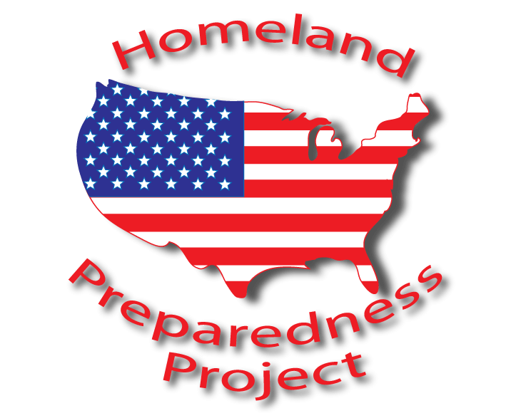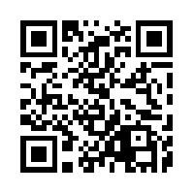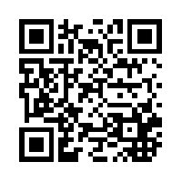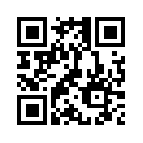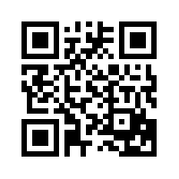

info@homelandpreparedness.org

Contact us by E-mail

www.homelandpreparedness.org

Visit our website

Follow us on Twitter

www.facebook.com/ReadyBrazoria

Follow us on Facebook